LAB 11

WEB TECHNOLOGY

ARCHITA AGRAHARI

22CS3015

**Web page performance analysis**

LIGHTHOUSE-

Site: <https://www.rgipt.ac.in/>

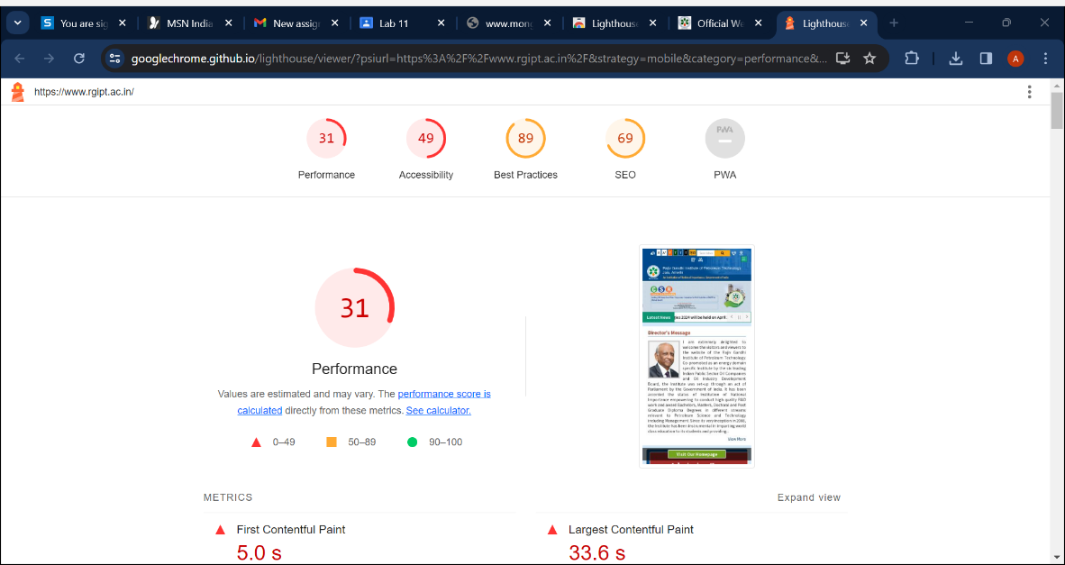

Site: <https://www.youtube.com/>

